Game Market

Code Reviews

24/03/2022 Eindhoven

Version: 1.0

Members:

Lars Kluijtmans: 4220269

Table of Contents

Version 3

Code Reviews 4

# Version

|  |  |  |  |  |
| --- | --- | --- | --- | --- |
| Version | Date | Author | Changes | Status |
| 1.0 | 16/06/2022 | Lars Kluijtmans | First edition | Finished |

# Code Reviews

## Review of downloading zip folder from google API by: Aleksej

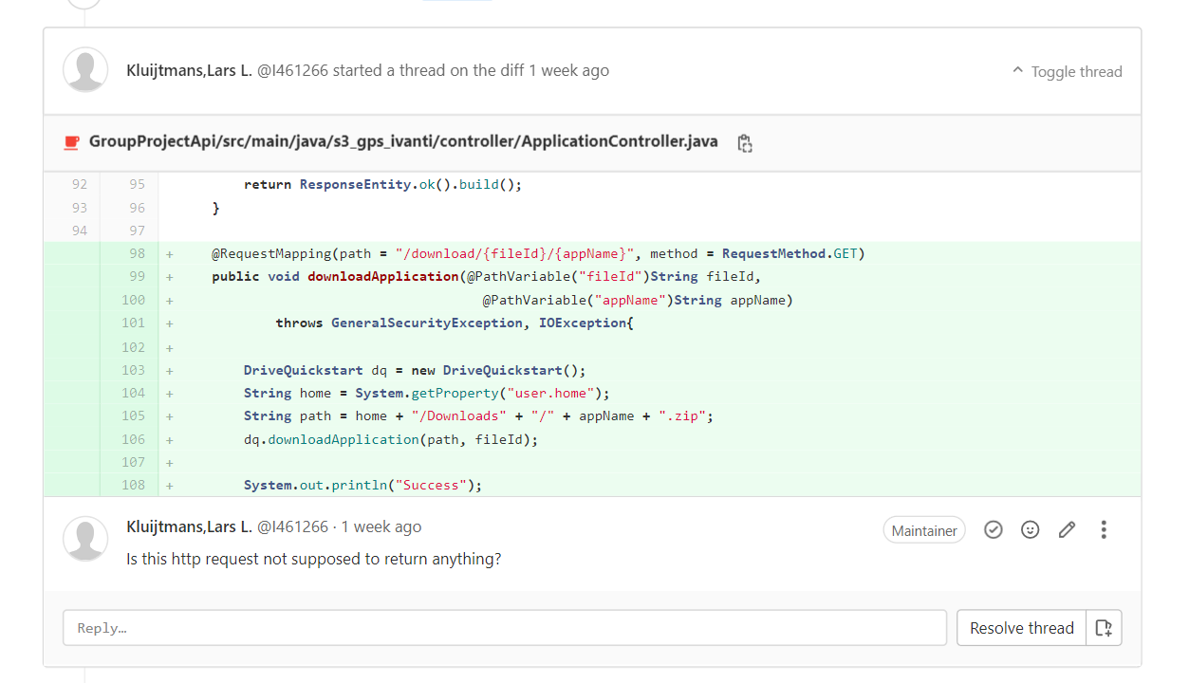

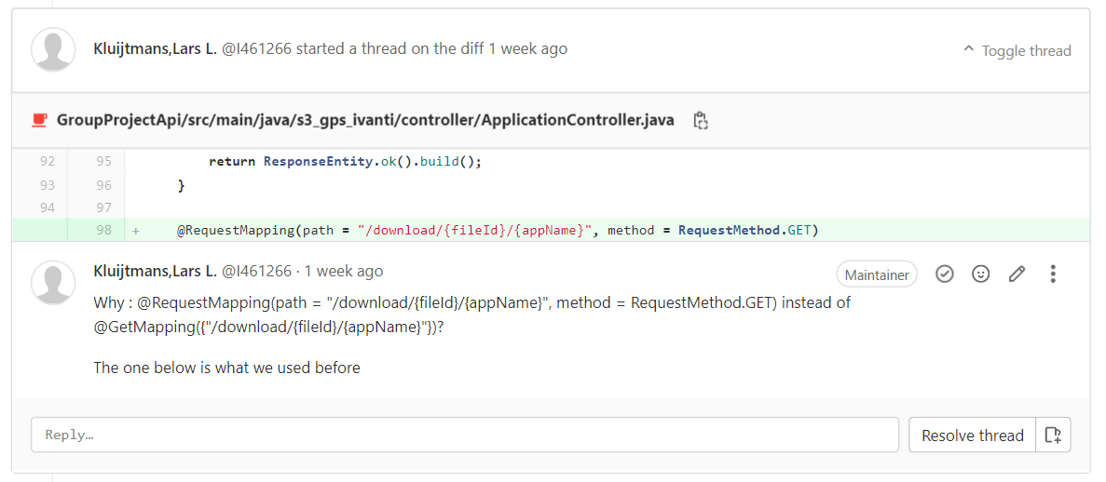

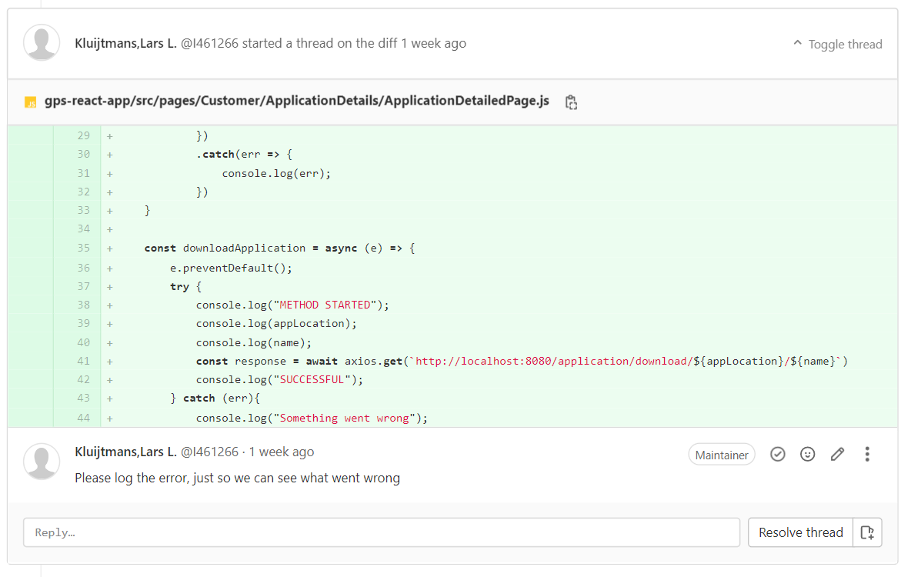

## Review of advanced statistics by: Mohammad

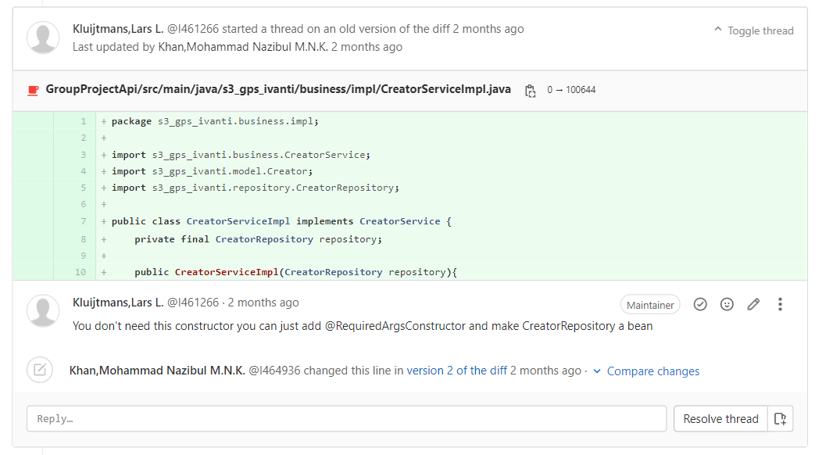

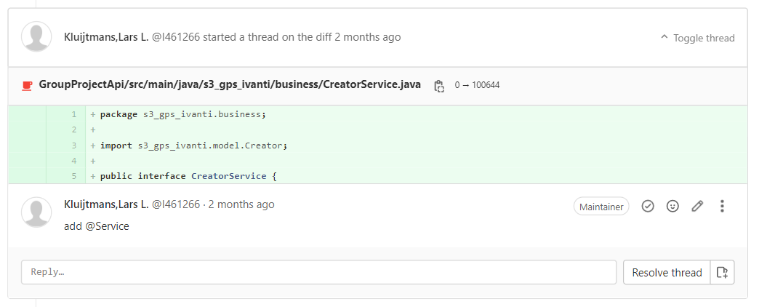

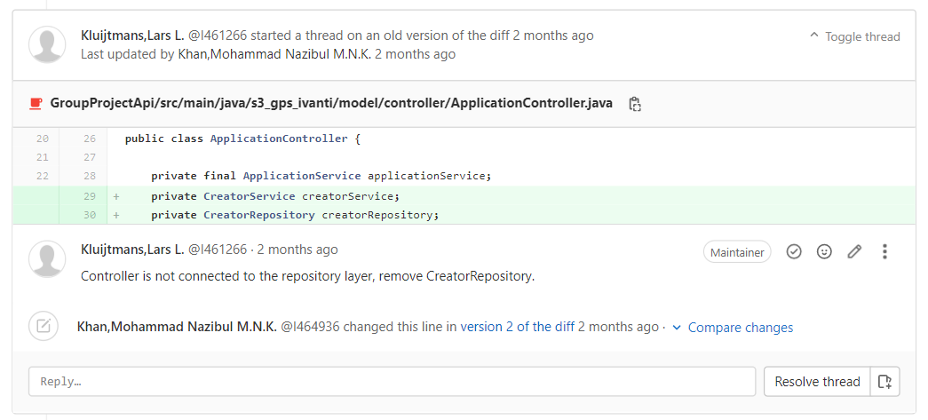

## Review of basic statistics by: Mohammads

